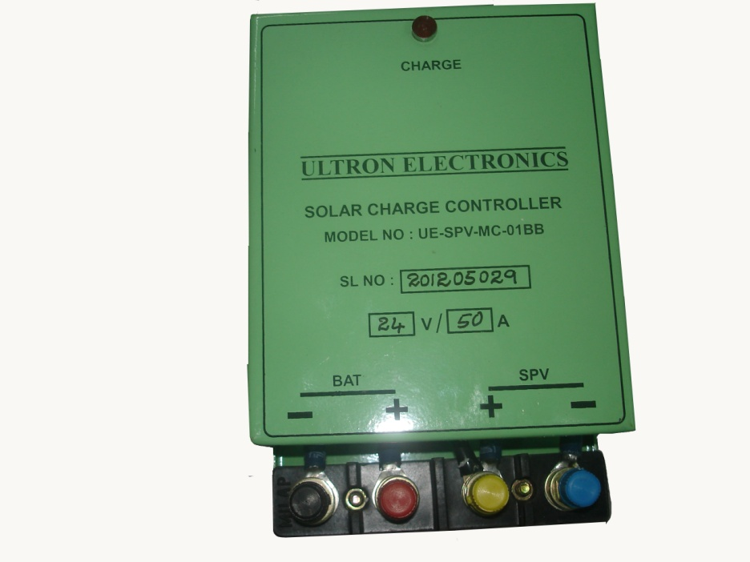

TECHNICAL SPECIFICATIONS FOR 24V/50A SOLAR CHARGE CONTROLLER WITH LOAD

a) Nominal Voltage : 12V or 24V DC
b) Max. Charging current : 50A
c) Deep Discharge protection : 10.5V/21.0V
d) Over Charge Protection : 14.4V/28.8V
e) Restart Of Charging : 12.5V/25V
f) Reconnection of Load : 12.5V/25V
g) Output load current : 10A Max.
h) Battery AH Rating : 100AH Max.
i) Solar Panel : 120Watts Max.
j) Operating Temp. : 50⁰ C
k) Self Consumption : 25ma

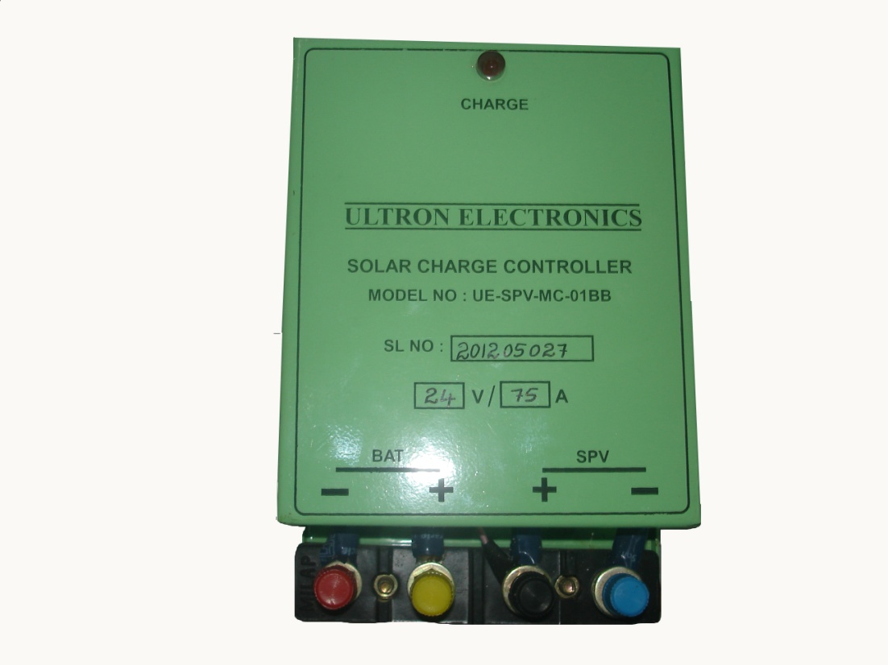

TECHNICAL SPECIFICATIONS FOR 24V/75A SOLAR CHARGE CONTROLLER WITH LOAD

a) Nominal Voltage : 12V or 24V DC
b) Max. Charging current : 75A
c) Deep Discharge protection : 10.5V/21.0V
d) Over Charge Protection : 14.4V/28.8V
e) Restart Of Charging : 12.5V/25V
f) Reconnection of Load : 12.5V/25V
g) Output load current : 10A Max.
h) Battery AH Rating : 100AH Max.
i) Solar Panel : 120Watts Max.
j) Operating Temp. : 50⁰ C
k) Self Consumption : 25ma

